Types of School Vehicles information provided by NJMVC
According to New Jersey law, a school vehicle is any vehicle used to transport children to or from school or any school-related activity, including day camp and summer camps, nursery school, childcare or preschools.

There are five types of school vehicles:

- Type A (transports 10-16 passengers)
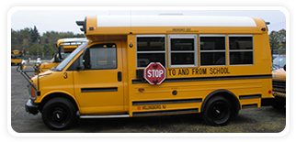
- Type B (transports 10-30 passengers)
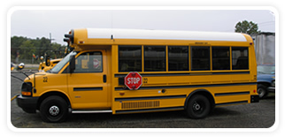
- Type C (transports 10-54 passengers)
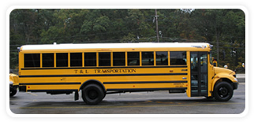

- Type D (transports 10-54 passengers)
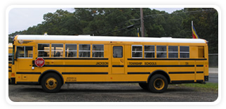
- Type S (transports 9 or less passengers)
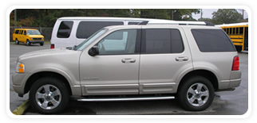
All vehicles must meet the regulations of MVC and either Department of Education or the Department of Children and Families, whichever is the supervising agency.

Registration
- Prior to registration, a vehicle must be titled, pass state’s inspection and receive authorization form SS-14 from MVC.

Is Your Child’s Bus Safe? Information provided by NJMVC
Checking your school bus:
- New Jersey has one of the most rigorous inspection processes in the country. In fact, MVC School Bus Inspection Unit inspects approximately 24,000 buses twice a year.

- Types of stickers
- Approval: Valid for six months once a bus passes a scheduled inspection

- 30-day rejection: Failure due to a less serious safety violation. Bus may be used for passenger transportation. All rejected items must be repaired and bus re-inspection within 30 days from date of initial inspection.

- Out-of-service: Inspection failure due to a major safety violation. Bus cannot be used for passenger transportation until all violations are repaired.

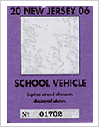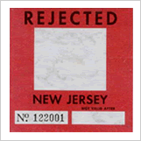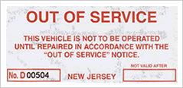

- School Bus Enhanced Safety Act (NJMVC)
  - Since enactment in 1998, the New Jersey School Bus Enhanced Safety Act has changed the way school buses are inspected. New Jersey has one of most stringent school bus inspection programs in the nation.

- Vehicle Subject to Bus Inspection
  - Vehicles subject to bus inspection are any motor vehicle operated by or under contract with a public or governmental agency, religious or other charitable organization or corporation or privately operated for compensation for the transportation of children to or from:
    - school or a school connected activity
    - day and summer camps
    - nursery, preschool and childcare centers
    - secular or religious education; or
    - other similar places of education

- Four Types of School Bus Inspections
  - SPECIFICATION INSPECTION: One-time inspection required for new school buses prior to registration; must meet all state and federal specifications to pass

  - SCHEDULED INSPECTION: Occurs every six months at bus company terminals after a bus passes the Specification Inspection and is registered

  - GOVERNOR'S SCHOOL BUS TASKFORCE INSPECTION: Bus Unit performs surprise or unannounced inspection at a bus terminal once a month
  - RECORD INSPECTION: Bus Unit inspects school bus records as part of the scheduled and Governor's School Bus Taskforce inspections including maintenance records, driver records (CDL, Physical, Criminal History) driver daily reports of buses, and driver employment

- Investigations
  - Complaint Investigations
  - Accident Investigations

Walk Safely Near Buses (NJMVC)
What is the danger zone?
  - Most school bus-related accidents occur within a 10-foot radius around the bus, where the driver has limited visibility. This area is called the "danger zone." It extends to 30 feet in front of the bus.

  - To avoid accidents, teach your child to use caution when getting on or off the bus and always to stay out of the danger zone.
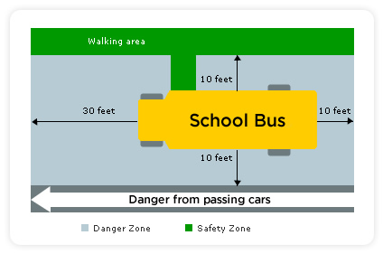

  - Teach your children helpful hints
    - Stay outside the danger zone and wait for the driver’s signal when getting on the bus and stay in a single file line
    - When getting off the bus, look to both sides before stepping off to make sure no cars are passing
    - Before crossing the street, take 5 GIANT steps away from the bus or until you can see the driver's face. Wait for the driver’s signal to know that it is safe to cross
    - Look left-right-left when you reach the edge of the bus to make sure traffic has stopped
    - Continue to watch for traffic when crossing
    - Always be seated with seat belts fastened while the bus is moving

Drive Safely Near Buses (NJMVC)
- Following the rules
  - It is very important to pay attention and follow all traffic rules when driving around school buses. All school buses have flashing lights and a stop arm to alert you when to stop.
- Flashing yellow lights
  - Yellow lights will begin to flash to warn drivers that a bus is approaching a stop. This is your signal to slow down and prepare to stop.
- Flashing Red lights
  - If you are approaching a school bus from either direction with flashing red lights, you must stop at least 25 feet away from the bus. If you are driving on the opposite side of the road with a median in the middle, you must then slow down to 10 mph.
- Extended stop arm
  - Do not pass a bus in either direction when its stop arm is extended. However, if the bus has stopped in front of a school, you may then pass it from either direction at no more than 10 mph.

School Bus Safety (NJSBCA)
Nothing is more important than the safety of our children. Janet Greer and Kelly Turner, Safety Specialists of the School Bus Company, offer some important safety tips for passengers and motorists.

      - For the children riding the bus:
- Never cross close to the front of the bus – make sure the driver can see you.
- Never pick up anything you drop close to or under the bus – ask the driver what to do.
- Never run after a bus or bang on the side.
- If you must cross the street in front of the bus, follow the driver’s directions, and stop and look before you cross.
- Never run across a street, it’s better to miss the bus than rush and risk being hit by a car.
- Stay away from the rear and sides of the bus – always be in a safe place where the driver can see you.

      - For drivers:
- Never pass a school bus when its stop lights are flashing.
- Be extra vigilant around school hours – assume a child might run out at any moment.
- Be courteous to school buses, give them room and let them change lanes when they need to.

      - For parents:
- Be at the bus stop five minutes before your children are scheduled to return from school. If the bus is delayed, get one of the group of parents to call the Township Transportation Department or the Bus Company providing the transportation.
- Always have a Plan B for when you can’t make it to the bus stop on time. If in the morning, know where the other stops are so you can meet the bus at those locations. If in the afternoon, coordinate with one of the other parents who are at the bus stop to pick up your child.
- Notify the authorities if something is suspicious at the bus stop. Get license plate numbers and a description of any persons who are not there to pick up children.
- Lunches should be eaten at lunch time, not on the bus. Avoid packing glass containers using foil packing for both drinks and food. Glass bottles and containers break and could jam the brake pedal of the school vehicle. Children should not be eating on the bus at any time.

      - Always remember:
- School bus drivers are not perfect. They are human and do make mistakes. However, School Bus Drivers are drug screened, pass a bi-annual physical, and are fingerprinted with the State of New Jersey and the Bread of the FBI for criminal activities that would prohibit them from operating a school bus. Every school bus driver loves their job. Their jobs are made easier when their passengers are well behaved and when the parents, school, and bus owners support them. Together we make the bus trip safer. Remember, your children are the safest when they are on the bus.

